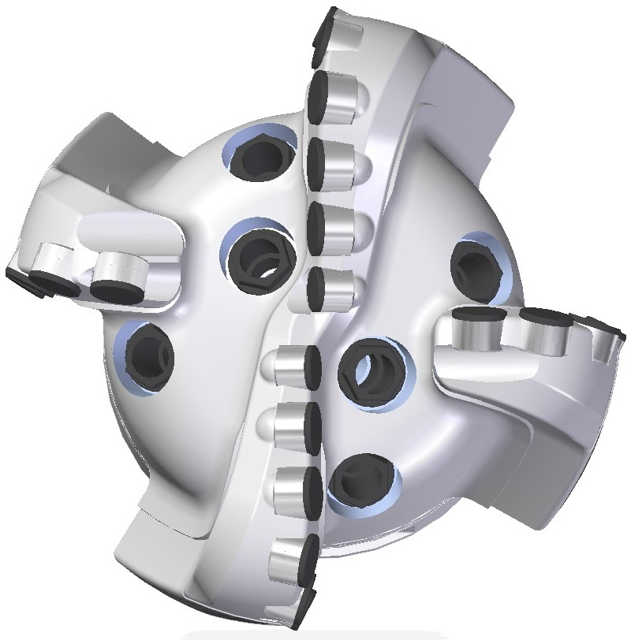 |  | 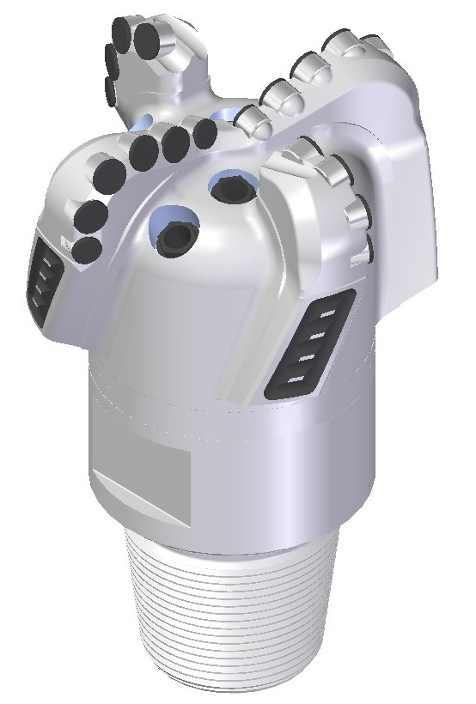

Drill Bit Specifications:
Cutter Size (Primary, Sec) |  | 3/4"
Cutter Count (Total, Gage) |  | 20
Blade Count |  | 4
Gage Length (Inches) |  | 2.50
Nozzle Count (Primary, Sec.) |  | 6
Nozzle Size (Primary, Sec.) |  | 60
JSA (Sq. Inches) |  | 22.04
Max. TFA (Sq. Inches) |  | 1.49
Operating Parameters:
Hydraulic Flow Rate (GPM) |  |  | 255 - 560
Make-Up Torque (FT-LBS) |  |  | 16488
Max. Weight on Bit (1,000 Lbs.) |  |  | 20
Nominal Dimensions:
Overall Length (Inches) | 13.92
Make Up Length (Inches) | 9.79
Bit Breaker | SKB-21010
Connection | Ø4-1/2" API Reg.
Approx. Weight (Lbs.) | 75

Standard Features:

- Large open face volume assists cuttings removal
- Six nozzles optimize blade cleaning and cuttings removal
- Premium grade cutters maximize ROP and Life
- Large cutters and fewer blades to maximize ROP
- Tapered gage for changing angle when pushed

419-SR6 Nomenclature Explained

- 4 = Number of blades
This design has two blades to center and two secondary blades.
- 19 = Primary Cutter Size (19mm)
- SR = Single Row of cutters per blade
- 6 = Number of nozzles
Interchangeable nozzles.

